After numerous attempts & fixes, I finally have some answers to each optimization. It is heavily dependent on upper bounds to give good results. Results also vary if we use the newer calculations or old assumptions.

Normal calculation: (standard spread & fr calc)

C:\Users\HB\Documents\GitHub\Microstimulation-Model\Images\test\optimize-standardsettings.tif

I think if I played more with the bounds, I may get better results. But I wanted to look at the previous spread function & FR calculations to compare.

The stimulation maps helped diagnose some issues, but by themselves they are difficult to use for displaying information:

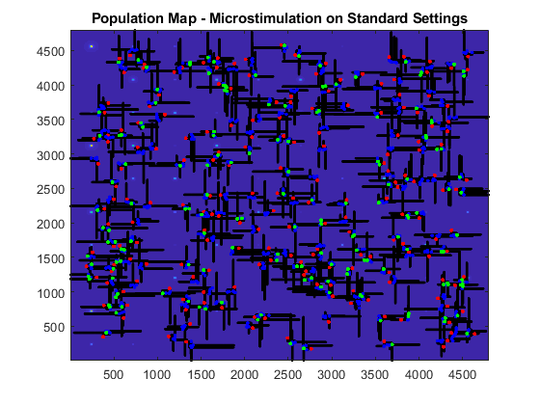

Type 1 solution (microstimulation stimulus intensity)



Type 4 solution (microstimulation stimulus intensity)



If we use the old spread functions but new FR calculations, we get very different results.



If we use the old spread function and old FR calculation.



Conclusions:

-I think the we may not be using the right FR calculation? OR our fit for the optical spread could use a change/look at. Both seem to be factors.

-Bounds need work. They are crucial to getting the best answers. Its possible I could get good results from what we have now, but I would need to dig more into it.

-If we added a multiplicative factor where opsin did not fully express in all cells, we would see a change.